**LAB 03**

**Object 01:**

Write a program to print 1 to n using while loop.

**Source Code:**

a=1

n=int(input("enter n number:"))

while(a<=n):

print(a)

a=a+1

**Output:**

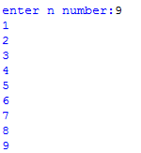

**Object 02:**

Write a program to print first n even and odd numbers.

**Source Code:**

n = int(input("enter n even & odd numbers:"));

i = 1;

j = 0;

while(i<=n):

print (i*2);

i = i + 1;

while(j<=n):

print (1+j*2);

j = j + 1;

**Output:**

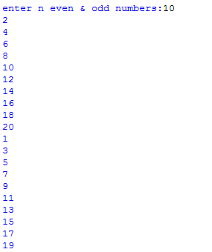

**Object 03:**

Write a program to print all natural numbers in reverse.

**Source Code:**

n=13

a=n

while(a>=1):

print(a)

a=a-1

**Output:**

C:\Users\EJAZ\Desktop\LAB 03\Capture 2.PNG

**Object 04:**

Write a program to print factorial of user’s input.

**Source Code:**

num=int(input("Enter a number: "))

factorial = 1

if(num<0):

print("Sorry, factorial does not exist for negative numbers")

elif(num==0):

print("The factorial of 0 is 1")

else:

for i in range(1,num + 1):

factorial = factorial*i

print("The factorial of",num,"is",factorial)

**Output:**

C:\Users\EJAZ\Desktop\LAB 03\Capture 04.PNG

**Object 05:**

Write a program to check whether the year entered by the user is leap year or not.

**Source Code:**

year=int(input("Enter a year: "))

if(year%4==0):

if(year%100==0):

if(year%400==0):

print("{0} is a leap year".format(year))

else:

print("{0} is not a leap year".format(year))

else:

print("{0} is a leap year".format(year))

else:

print("{0} is not a leap year".format(year))

**Output:**

C:\Users\EJAZ\Desktop\LAB 03\Capture 05.PNG

**Object 06:**

Write a program to calculate Mean, Variance and Standard Deviation.

**Source Code:**

import math

numbers = []

add = 0

mean = 0

b = 0

for _ in range(5):

numbers.append(eval(input("Enter number: ")))

for i in range(5):

add += numbers[i]

mean = add//len(numbers)

for i in range(5):

a = abs(mean-numbers[i])**2

b += a

variance = round(b//5, 2)

std_dev = round(math.sqrt(variance),2)

print("Mean:", mean)

print("Variance:", variance)

print("Standard Deviation", std_dev)

**Output:**

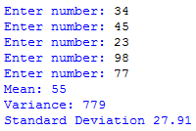

**Object 07:**

Write a program to print multiplication table using while loop.

**Source Code:**

a=int(input("Multiplication using value: "))

while(a<=10):

i=1

while(i<=a):

product=a*i

print(a,"*",i,"=",product,"\n")

i=i+1

print("\n")

a=a+1

**Output:**

